**COMSATS University Islamabad,**

**Abbottabad Campus**

**SOFTWARE REQUIREMENTS SPECIFICATION   
(SRS DOCUMENT)**

**for**

**<E Book Reader and Downloader>**  
Version 1.0

**ATD**

***By***

**Sayed Shah Mohsin FA2-BSE-035**

**Baryal Rehman FA20-BSE-038**

***Supervisor*Mam Neeli Khan**

***Bachelor of Science in Computer Science (2020-2024)***

**Table of Contents**

**Revision History 3**

**1.** **Introduction 5**

1.1 Purpose 5

1.2 Scope 5

**2.** **Overall description 5**

2.1 Product perspective 5

2.2 Operating environment 5

2.3 Design and implementation constraints 5

**3.** **Requirement identifying technique 6**

3.1 Use Case Diagram 6

3.2 Use Case Description 6

**4.** **Specific Requirements 8**

4.1 System feature X 8

**5.** **Quality attributes** Error! Bookmark not defined.

5.1 Usability 9

5.2 Performance 9

**6.** **External interface requirements 35**

6.1 User interfaces 35

6.2 Software interfaces 35

6.3 Hardware interfaces 35

6.4 Communications interfaces 35

**7.** **Project Gantt chart 35**

**8.** **References 10**

**Revision History**

|  |  |  |  |
| --- | --- | --- | --- |
| **Name** | **Date** | **Reason for changes** | **Version** |
|  |  |  |  |
|  |  |  |  |

**Application Evaluation History**

|  |  |
| --- | --- |
| **Comments (by committee)**  **\*include the ones given at scope time both in doc and presentation** | **Action Taken** |
|  |  |
|  |  |

**Supervised by**

**<Neeli Khan>**

Signature______________

**Introduction**

E-Book Reader and Downloader application is designed to offer an exceptional and user-friendly platform for book enthusiasts, using the power of React Native programming language with state-of-the-art tools and techniques. Our primary aim is to create a feature-rich ecosystem for reading and downloading books seamlessly.

We will outline the key modules and features that E-Book Central will offer, including user registration and login, a comprehensive book catalog, an immersive book reading experience with E Pub Viewer integration, efficient state management, and secure storage for favorites and downloaded content with Firebase. E-Book Central is driven by the motivation to cater to the practical needs of book lovers, ensuring a convenient and enjoyable reading experience. By using advanced technologies and integrating essential features, we are confident that this app will not only meet but exceed the expectations of book readers, providing them with a versatile and delightful platform for their literary pursuits.

**Purpose**

The specifications for the development of the E-Book Reader and Downloader application, affectionately named "E-Book Central." The primary purpose of this application is to provide an exceptional and user-friendly platform tailored for book enthusiasts. Leveraging the power of the React Native programming language and incorporating state-of-the-art tools and techniques, our goal is to establish a feature-rich ecosystem that seamlessly facilitates both the reading and downloading of books. E-Book Central aims to address the practical needs of avid readers, offering a convenient and enjoyable reading experience. The application's key modules include user registration and login functionalities, an extensive book catalog, an immersive book reading experience with E Pub Viewer integration, efficient state management, and secure storage for favorites and downloaded content using Firebase.

**Scope**

Admin is responsible for physical storage or uploading of new books. Also, authors can create profiles and upload their own books. Focus is on serving a unique platform to every book lover. Reading and downloading processes will be handled separately by Users. Platform will provide book reviews service. Focuses on promoting creativity in the readers and writer’s realm. Providing a smooth, user-friendly experience for both Readers and Authors.

**Overall description**

**Product perspective**

The E-Book Reader and Downloader application, known as "E-Book Central," emerges as the latest addition to a growing line of innovative digital reading solutions. Unlike its predecessors, E-Book Central is not merely a version upgrade or replacement for an existing application; it represents an entirely new product designed to redefine the reading experience across diverse platforms.

This novel application is meticulously crafted to be responsive across various mobile devices, ensuring a consistent and enjoyable user experience regardless of the device's specifications. By embracing emerging technologies and addressing the evolving needs of readers, E-Book Central stands as a testament to the commitment to push the boundaries of what a modern e-book reader and downloader can achieve.

**Operating environment**

OE-1: E-Book Central is designed to operate seamlessly on various mobile devices, including smartphones and tablets, across popular platforms such as iOS and Android.

OE-2: The application will be optimized for compatibility with major web browsers, including but not limited to Google Chrome, Mozilla Firefox, Apple Safari, and Microsoft Edge, ensuring a consistent user experience regardless of the chosen browser.

OE-3: E-Book Central requires an internet connection for initial registration, login, and book downloads. However, once books are downloaded, users can enjoy offline reading functionality.

OE-4: The application's servers and databases are hosted on secure cloud infrastructure, providing scalability, reliability, and efficient data management. The geographical distribution of these servers aims to minimize latency and optimize performance for users across different regions.

OE-5: E-Book Central employs Firebase for secure storage of user favorites and downloaded content, enhancing data security and accessibility.

**Design and implementation constraints**

CO-1: E-Book Central shall utilize the React Native programming language for development. This constraint is driven by the need for a cross-platform framework that enables the efficient creation of both iOS and Android applications with a shared codebase, reducing development time and effort.

CO-2: The application shall integrate with Firebase for user authentication, favorites, and downloaded content storage. This constraint is imposed to leverage Firebase's secure and scalable backend services, ensuring efficient data management and user authentication.

CO-3: E-Book Central shall incorporate the EPub Viewer library for rendering and displaying e-books in the EPub format. This constraint is chosen to enhance the reading experience by utilizing a proven and widely adopted library for EPub rendering.

CO-4: The application's frontend shall be designed using Material Design principles for a cohesive and visually appealing user interface. This constraint ensures consistency in design across various platforms and contributes to a positive user experience.

CO-5: E-Book Central shall be designed to operate on devices with a minimum screen size of 5 inches. This constraint is set to optimize the user interface and reading experience, considering the limitations of smaller screens

**Requirement identifying technique.**

The use case technique proves to be a valuable method for identifying functional requirements, especially in the context of interactive end-user applications. It provides a structured approach to capturing and specifying the various interactions and functionalities that users can perform within the system. For the E-Book Reader and Downloader application, the use case technique is particularly effective in delineating user interactions and system responses, ensuring a comprehensive understanding of the required functionalities.

**Use case diagram**

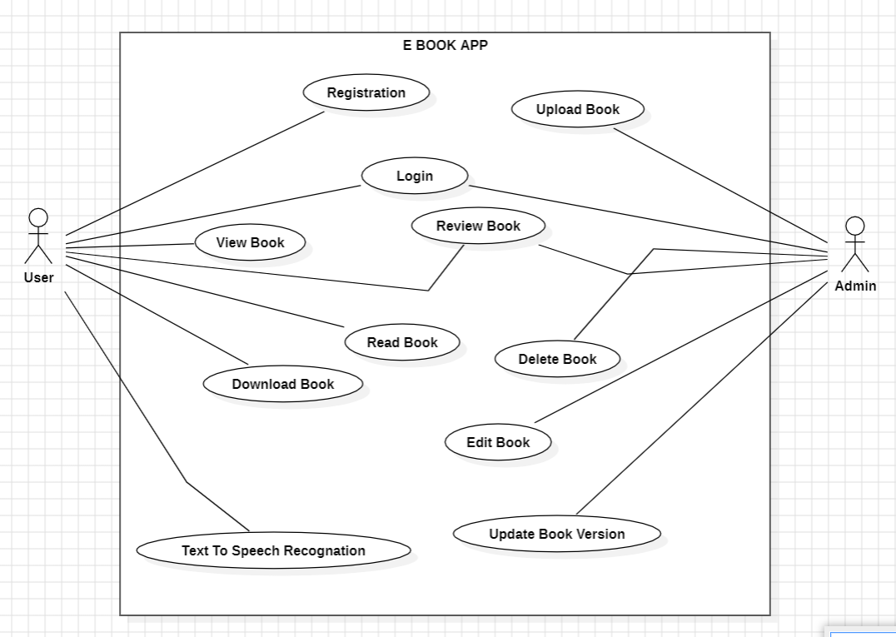

**Use case description.**

### Use Case: Register Account

|  |  |
| --- | --- |
| **Use Case ID:** | UC-1 |
| **Use Case Name:** | Register Account |
| **Actors:** | User   |  |  |  |  | | --- | --- | --- | --- | |  |  |  |  | |
| **Description:** | Allows a user to register a new account on the E Book Mobile App |
| **Trigger:** | The user indicates the desire to create a new account. |
| **Preconditions:** | None |
| **Postconditions:** | A new account is created and the user and admin is logged in. |
| **Normal Flow:** | 1. User navigates to the registration page. 2. User enters the required information. 3. User submits the registration form. 4. System validates the information and creates a new account. 5. User is automatically logged in. |
| **Alternative Flows:**  **[** | None |
| **Exceptions:** | None. |

### 

### Use Case: Login

|  |  |
| --- | --- |
| **Use Case ID** | **UC-2** |
| Use Case Name | Login |
| Actors | User and admin |
| Description | Allows a registered user to log in to their account. Admin login |
| Trigger | The user and admin indicates the desire to log in. |
| Preconditions | The user must have a registered account. |
| Postconditions | The user and login is logged in to their account. |
| Normal Flow | 1. User navigates to the login page. 2. User enters their username and password. 3. User submits the login form. 4. System verifies the credentials and logs in the user. |
| Alternative Flows | None |
| Exceptions | None |

### Use Case: View Book

|  |  |
| --- | --- |
| **Use Case ID** | **UC-3** |
| Use Case Name | View Book |
| Actors | User |
| Description | Allows a user to viewing a book on the E-Book Mobile App. |
| Trigger | The user expresses the desire to contribute a brief comment or answer while reading a book. |
| Preconditions | User and admin logged into the E-Book Mobile App.  The user is currently viewing a book. |
| Post conditions | The user's one-line answer or comment is successfully added to the book. |
| Normal Flow | User is reading a book and decides to add a one-line answer or comment.  2. User locates the option to add a comment within the book interface.  User inputs the one-line answer or comment.  4. User submits the comment.  **The system adds the user's comment to the book |
| Alternative Flows | None |
| Exceptions | None |

### Use Case: Download Book

|  |  |
| --- | --- |
| **Use Case ID** | **UC-4** |
| Use Case Name | Download Book |
| Actors | User |
| Description | Allows a user to download a book from the E-Book Mobile App for offline reading. |
| Trigger | The user expresses the desire to download a book for offline access. |
| Preconditions | User and admin are logged into the E-Book Mobile App.  The user is currently viewing a book |
| Post conditions | The selected book is successfully downloaded and stored on the user's device. |
| Normal Flow | User is viewing a book and decides to download it for offline access.  2. User locates the option to download within the book interface.  User initiates the download process.  4. The system retrieves and downloads the book content.  **The downloaded book is stored on the user's device for offline reading. |
| Alternative Flows | None |
| Exceptions | None |

### Use Case: Read Book

|  |  |
| --- | --- |
| **Use Case ID** | **UC-5** |
| Use Case Name | Read Book |
| Actors | User |
| Description | Allows a user to read a book from the E-Book Mobile App. |
| Trigger | The user expresses the desire to read a book. |
| Preconditions | User and admin logged into the E-Book Mobile App.  The user has either downloaded a book or has access to online reading. |
| Post conditions | The user successfully reads the selected book. |
| Normal Flow | User decides to read a book.  2. If the book is downloaded, the user opens the app and locates the downloaded book; otherwise, the user browses the catalog to find an online book to read.  User selects the desired book for reading.  4. The system opens the book in the reading interface.  **User navigates through the pages and reads the book content |
| Alternative Flows | None |
| Exceptions | None |

### Use Case: Text-to-Speech Recognition

|  |  |
| --- | --- |
| **Use Case ID** | **UC-6** |
| Use Case Name | Text-to-Speech Recognition |
| Actors | User |
| Description | Allows a user to enable text-to-speech recognition while reading a book on the E-Book Mobile App. |
| Trigger | The user expresses the desire to use text-to-speech functionality during book reading. |
| Preconditions | Users and admin are logged into the E-Book Mobile App.  The user is currently viewing a book |
| Post conditions | The selected book is read aloud using text-to-speech technology. |
| Normal Flow | The user is reading a book and decides to enable text-to-speech.  2. User locates the option for text-to-speech within the reading interface.  User activates the text-to-speech functionality.  4. The system processes the text and converts it into speech.  **The book content is read aloud to the user. |
| Alternative Flows | None |
| Exceptions | None |

### Use Case: Review Book

|  |  |
| --- | --- |
| **Use Case ID** | **UC-7** |
| Use Case Name | Review Book |
| Actors | User, Admin |
| Description | Allows a user to submit a review for a book, and both users and admins can view book reviews on the E-Book Mobile App. |
| Trigger | The user expresses the desire to submit a review for a book, and both users and admins want to view book reviews. |
| Preconditions | Users and admins are logged into the E-Book Mobile App.  The user has either read a book or is in the process of reading a book. |
| Post conditions | The user's review is successfully submitted, and both users and admins can view book reviews. |
| Normal Flow | User finishes reading a book and decides to submit a review.  2. User locates the option to submit a review within the book interface.  User writes and submits the review.  4. The system stores the review in the database associated with the book. |
| Alternative Flows | None |
| Exceptions | None |

### Use Case: Upload Book

|  |  |
| --- | --- |
| **Use Case ID** | **UC-8** |
| Use Case Name | Upload Book |
| Actors | Admin |
| Description | Allows an admin to upload a new book to the E-Book Mobile App. |
| Trigger | The admin expresses the desire to add a new book to the app. |
| Preconditions | Admin is logged into the E-Book Mobile App. |
| Post conditions | A new book is successfully uploaded and added to the app's catalog. |
| Normal Flow | Admin navigates to the book upload section within the app.  2. Admin provides details about the new book, including title, author, genre, and file upload.  Admin submits the book information.  4. The system validates and processes the uploaded book information.  **The new book is added to the app's catalog and becomes accessible to users. |
| Alternative Flows | None |
| Exceptions | None |

### Use Case: Delete Book

|  |  |
| --- | --- |
| **Use Case ID** | **UC-9** |
| Use Case Name | Delete Book |
| Actors | Admin |
| Description | Allows an admin to delete a book from the E-Book Mobile App. |
| Trigger | The admin expresses the desire to remove a book from the app. |
| Preconditions | Admin is logged into the E-Book Mobile App. |
| Post conditions | The selected book is successfully deleted from the app's catalog. |
| Normal Flow | Admin navigates to the book management section within the app.  2. Admin selects the book to be deleted.  Admin confirms the deletion action.  4. The system removes the selected book from the app's catalog. |
| Alternative Flows | None |
| Exceptions | None |

### Use Case: Edit Book

|  |  |
| --- | --- |
| **Use Case ID** | **UC-10** |
| Use Case Name | Edit Book |
| Actors | Admin |
| Description | Allows an admin to edit the details of a book in the E-Book Mobile App. |
| Trigger | The admin expresses the desire to modify the information of an existing book. |
| Preconditions | Admin is logged into the E-Book Mobile App. |
| Post conditions | The selected book's details are successfully updated in the app's catalog. |
| Normal Flow | Admin navigates to the book management section within the app.  2. Admin selects the book to be edited.  Admin modifies the necessary details of the book (e.g., title, author, genre).  4. Admin submits the updated book information.  The system validates and processes the edited book information.  6. The selected book's details are updated in the app's catalog. |
| Alternative Flows | None |
| Exceptions | None |

### Use Case: update version Book.

|  |  |
| --- | --- |
| **Use Case ID** | **UC-11** |
| Use Case Name | Update Version of Book |
| Actors | Admin |
| Description | Allows an admin to update the version of a book in the E-Book Mobile App. |
| Trigger | The admin expresses the desire to release a new version of an existing book. |
| Preconditions | Admin is logged into the E-Book Mobile App. |
| Post conditions | The selected book's version is successfully updated in the app's catalog. |
| Normal Flow | Admin navigates to the book management section within the app.  2. Admin selects the book for which a new version is to be released.  Admin provides the details of the updated version (e.g., version number, release notes). |
| Alternative Flows | None |
| Exceptions | None |

**Functional Requirements**

### Functional Requirement FR-001: User Registration

|  |  |
| --- | --- |
| **Identifier** | **FR-001** |
| Title | User Registration |
| Requirement | Allow users to create an account on the website by providing necessary information such as username, email, and password. |
| Source | User requirement |
| Rationale | Users need to have a registered account to access personalized features and participate in the website's community. |
| Business Rule | N/A |
| Dependencies | N/A |
| Priority | High |

### Functional Requirement FR-002: User and Admin Login

|  |  |
| --- | --- |
| **Identifier** | **FR-002** |
| Title | User, Admin Login |
| Requirement | Provide a login mechanism for registered users to access their accounts using their credentials (username/email and password). |
| Source | User requirement |
| Rationale | Users need to authenticate themselves to gain access to their personalized settings, saved recipes, and other account-related features. |
| Business Rule | N/A |
| Dependencies | FR-001 |
| Priority | High |

### Functional Requirement FR-003: User View Book

|  |  |
| --- | --- |
| **Identifier** | **FR-003** |
| Title | View Book |
| Requirement | Allow users to view details of a book, including title, author, genre, and content. |
| Source | User requirement |
| Rationale | Users should be able to explore and access information about books available in the app. |
| Business Rule | N/A |
| Dependencies | N/A |
| Priority | High |

### Functional Requirement FR-004: User Download Book

|  |  |
| --- | --- |
| **Identifier** | **FR-004** |
| Title | Download Book |
| Requirement | Allow users to download a book for offline reading. |
| Source | User requirement |
| Rationale | Users should have the ability to download books and access them offline for convenience |
| Business Rule | N/A |
| Dependencies | N/A |
| Priority | High |

### Functional Requirement FR-005: Read Book

|  |  |
| --- | --- |
| **Identifier** | **FR-005** |
| Title | Read Book |
| Requirement | Allow users to read a book within the E-Book Mobile App |
| Source | User requirement |
| Rationale | Users should be able to access and enjoy the content of the books directly within the app. |
| Business Rule | N/A |
| Dependencies | FR-004 (Download Book) |
| Priority | High |

### Functional Requirement FR-006: Text to Speak Recognition

|  |  |
| --- | --- |
| **Identifier** | **FR-006** |
| Title | Text-to-Speech Recognition |
| Requirement | Provide a feature that allows users to enable text-to-speech recognition while reading a book in the E-Book Mobile App. |
| Source | User requirement |
| Rationale | Users may prefer to have the content of a book read aloud for accessibility or convenience. |
| Business Rule | N/A |
| Dependencies | FR-005 (Read Book) |
| Priority | High |

### Functional Requirement FR-007: Review Book

|  |  |
| --- | --- |
| **Identifier** | **FR-007** |
| Title | Review Book |
| Requirement | Allow users and admins to submit reviews for a book, and provide the functionality for both users and admins to view book reviews in the E-Book Mobile App.  Source: User requirement. |
| Source | User requirement |
| Rationale | Reviews contribute to the community engagement and assist users in making informed choices about books. |
| Business Rule | N/A |
| Dependencies | N/A |
| Priority | High |

### Functional Requirement FR-008: Delete Book

|  |  |
| --- | --- |
| **Identifier** | **FR-008** |
| Title | Delete Book |
| Requirement | Allow admins to delete a book from the E-Book Mobile App. |
| Source | Admin requirement |
| Rationale | Admins should have the capability to manage the content within the app, including the removal of books |
| Business Rule | N/A |
| Dependencies | N/A |
| Priority | High |

### Functional Requirement FR-009: Edit Book

|  |  |
| --- | --- |
| **Identifier** | **FR-009** |
| Title | Edit Book |
| Requirement | Allow admins to edit the details of a book in the E-Book Mobile App. |
| Source | Admin requirement |
| Rationale | Admins should have the capability to update information about a book, such as title, author, genre, etc. |
| Business Rule | N/A |
| Dependencies | N/A |
| Priority | High |

### Functional Requirement FR-010: Update version Book

|  |  |
| --- | --- |
| **Identifier** | **FR-010** |
| Title | Update Version of Book |
| Requirement | Allow admins to update the version of a book in the E-Book Mobile App. |
| Source | Admin requirement |
| Rationale | Admins should have the capability to release new versions of existing books with updated content or features. |
| Business Rule | N/A |
| Dependencies | N/A |
| Priority | High |

**Non Functional Requirements**

**Usability**

USE-1: The E-Book Mobile App shall have an intuitive and user-friendly interface to facilitate ease of learning.

USE-2: Users should be able to navigate the app easily, with clear menus and navigation paths.

USE-3: The app shall provide error messages that are clear, concise, and guide users on how to recover from errors.

USE-4: The E-Book Mobile App shall be designed for efficient interactions, minimizing the number of steps required to perform common tasks.

USE-5: The app shall be accessible to users with disabilities, adhering to relevant accessibility standards.

**Performance**

Refer PERF-1: The app's response time for common actions, such as opening a book or submitting a review, shall be within 2 seconds.

PERF-2: The app shall handle concurrent user interactions, supporting a minimum of 500 simultaneous users.

PERF-3: The time taken to download a book for offline reading shall not exceed 5 minutes under standard network contingences.

**Reliability:**

REL-1: The app shall have a system to back up user account information regularly to prevent data loss.

REL-2: The app shall be available for use 99% of the time, excluding planned maintenance periods.

**Security:**

SEC-1: User passwords shall be stored securely using industry-standard encryption algorithms.

SEC-2: The app shall have role-based access control, ensuring that only authorized admins can perform administrative tasks.

SEC-3: User data, including personal information and reading history, shall be encrypted during transmission and storage.

**Scalability**:

SCAL-1: The app's architecture shall support a growth in the user base by 20% per year for the next three years without significant degradation in performance.